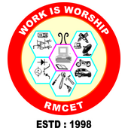 | Prabodhan Shikshan Prasarak Sanstha’s  Rajendra Mane College of Engineering and Technology, Ambav (Devrukh)  Department of Mechanical Engineering  A  Webinar on  “Introduction to BMS-MEP Engineering”  By Mr. Museb Modak  Date: 25/03/2022  MECHANICAL ENGINERING DEPARTMENT. RMCET DEVRUKH

Mechanical Engineering Department successfully conducted A Webinar on “Introduction to MBMS-MEP Engineering” on 25/03/2022 At MECHANICAL ENGINERING DEPARTMENT, RMCET DEVRUKH by Mr. Museb Modak, Project Engineer at SIEMENCE LLP, ABU DHABI (UAE) having 4 years of experience in the field of HVAC & R.

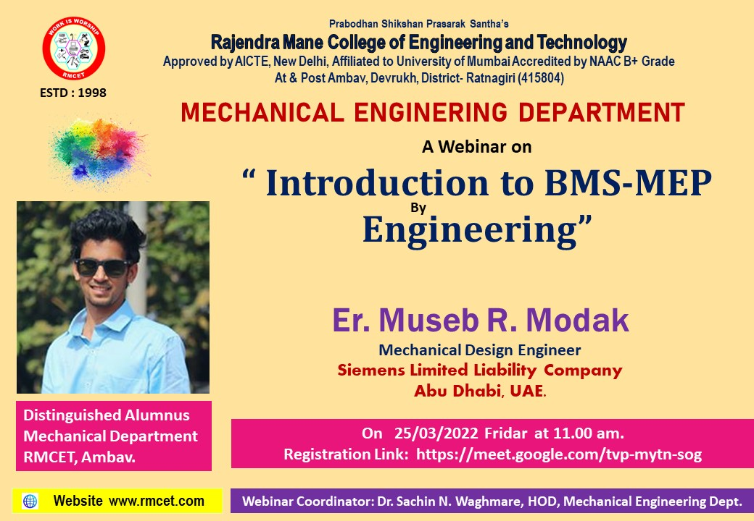
(Flyer of the webinar)

During the webinar Mr. Museb Modak explained & shown following points.
- Basics of BMS & MEP in HVAC
- AHU Unit demonstration
- Pumps section
- Temperature, Flow, Humidity measuring devices demonstration

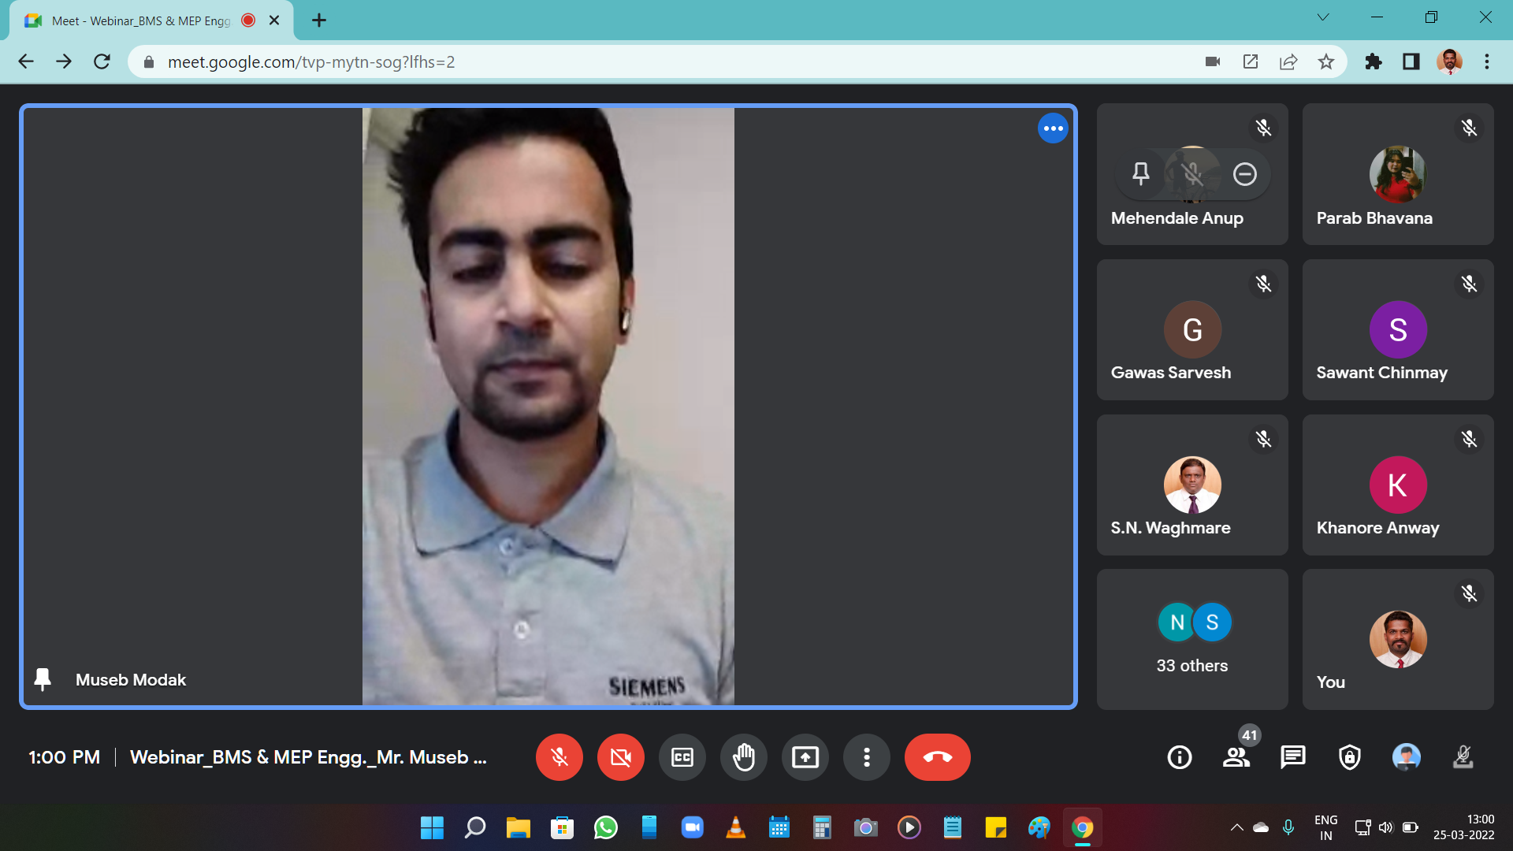
(Speaker conducting the session)

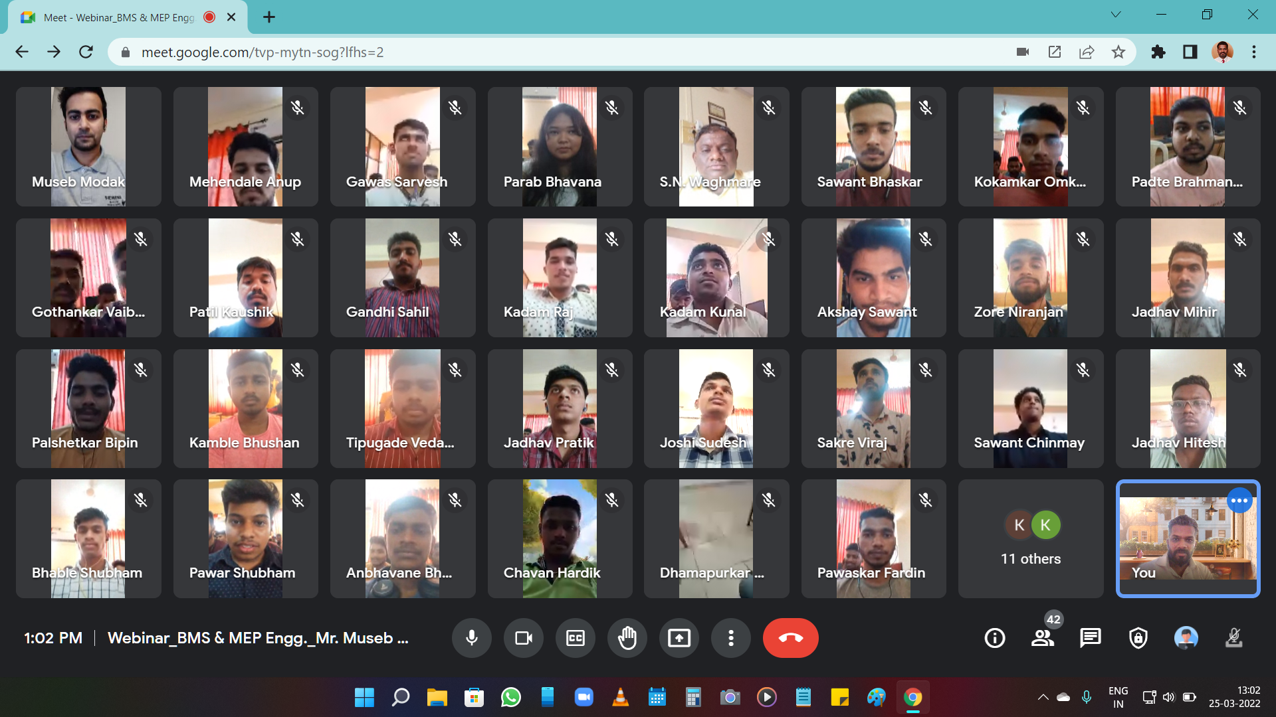
(Students attending the webinar using Google Meet App)

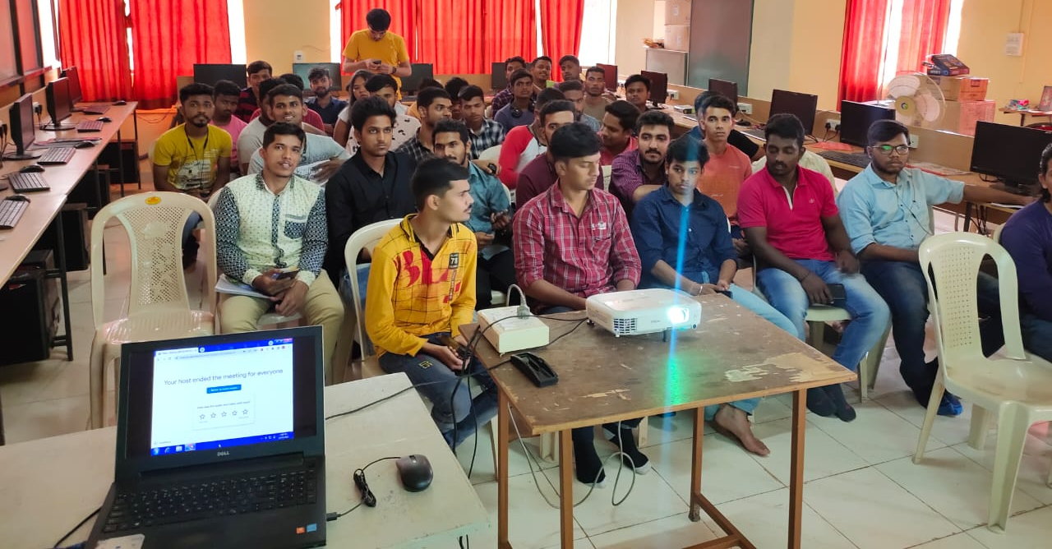

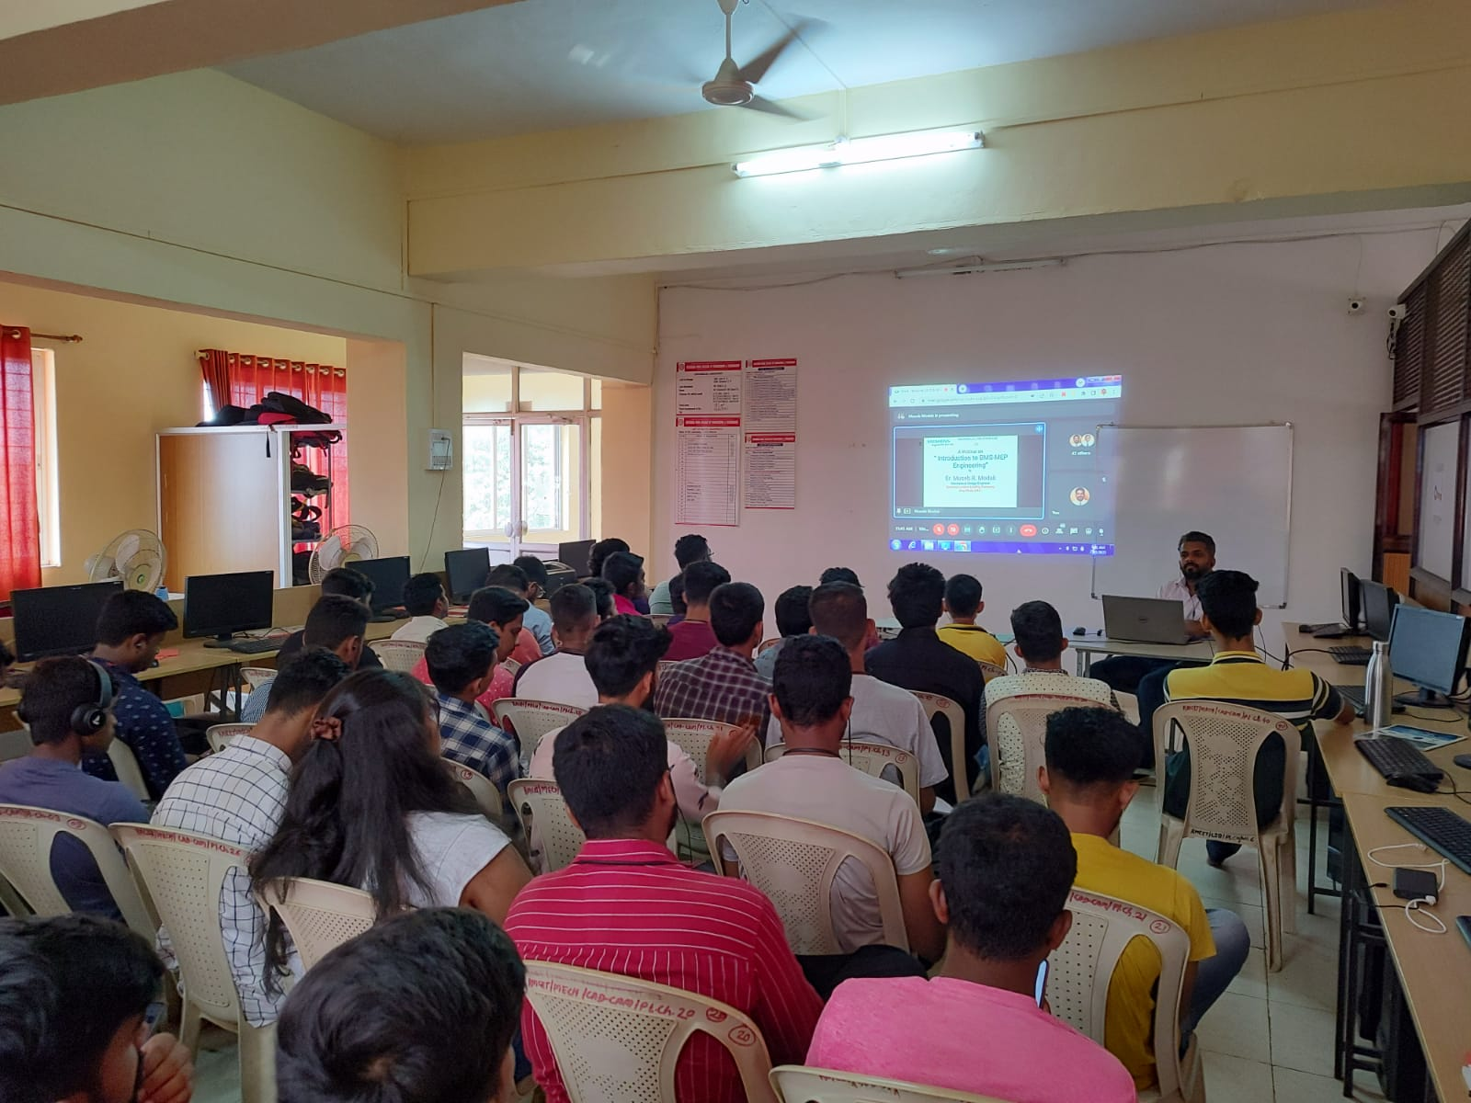
(Students attending the webinar in CAD/CAM Lab)
Total 43 students of TE Mechanical Engineering class attended the webinar. The webinar was coordinated by
Mr. V. K. Dongare, Assistant Professor under the guidance of Dr. S. N. Waghmare, HOD, Mechanical Engineering Department, RMCET Devrukh.

